OBJECT ORIENTED MODELLING
& DESIGNING
REPORT
HOTEL MANAGEMENT SYSTEM
Course Code: 410241

Submitted by: Avaneesh Joshi
Roll No.: BC227
Class / Division: BE-2

Department: Computer
Academic Year: 2026-27

TITLE
Hotel Management System
Object Oriented Modelling and Design using UML
Problem Statement
Hotels still depend on registers, spreadsheets and phone calls to handle room bookings, guest records and payments. This manual approach is slow and error-prone. Rooms are double-booked, availability is not known in real time, reservations and cancellations are not recorded consistently, bills contain mistakes, and managers cannot easily see occupancy or revenue. Customers also have no convenient way to search rooms, book them and pay online.
The aim of this project is to analyse and model a computerised Hotel Management System that automates these activities. The system must let customers register, log in, search for rooms, check availability, book and cancel reservations, and make payments. It must let receptionists handle check-in, check-out and billing, housekeepers update room status after cleaning, and managers manage rooms, customers and employees and generate reports. All data must be stored securely in a central database, and payments must be processed through an external payment gateway.
Objectives
- Accuracy: prevent double bookings by checking room availability and updating room status automatically.
- Convenience: allow customers to search, book, cancel and pay through a web or mobile interface.
- Efficiency: reduce the receptionist's workload for check-in, check-out and bill generation.
- Management control: give managers reports on rooms, customers, employees and revenue.
- Reliability and security: store all records in a central SQL database with backup, and use secure communication (HTTPS and a secure payment API).
Scope
The system covers room management, customer registration and login, reservation, payment, check-in and check-out, billing and reporting. Its users (actors) are the Customer, Receptionist, Manager and Housekeeper. The Payment Gateway is an external system.
Modelling Approach
The problem is modelled with UML in the following order: Class Diagram (static structure), State Model (system behaviour over time), Deployment Diagram (physical architecture), Activity Diagram (booking workflow), Use Case Diagram (user functions) and Component Diagram (software modules and interfaces). Each diagram is described on the pages that follow, together with its key elements.
1. Class Diagram
A class diagram is a static structural UML diagram that shows the classes of a system, their attributes and operations, and the relationships between them.
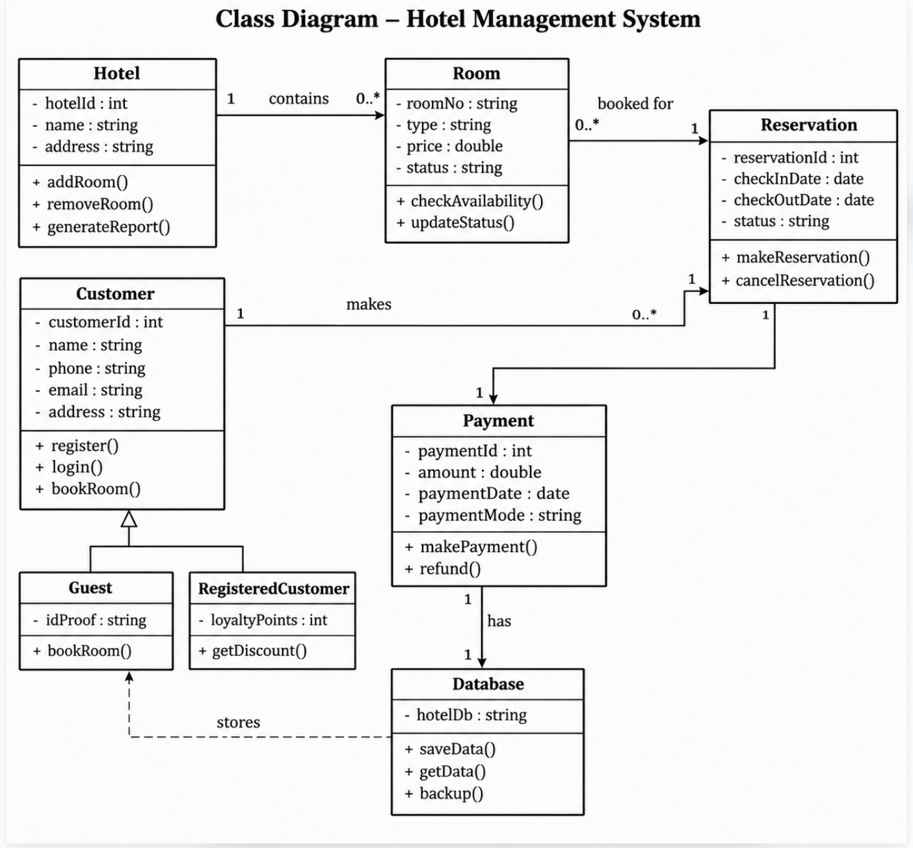
Description
This diagram models the main classes of the Hotel Management System. The Hotel class (hotelId, name, address) manages rooms through addRoom(), removeRoom() and generateReport(). One Hotel contains zero or more Room objects, and each Room stores roomNo, type, price and status, with checkAvailability() and updateStatus() operations.
A Room is booked for a Reservation (reservationId, checkInDate, checkOutDate, status), which supports makeReservation() and cancelReservation(). One Customer (customerId, name, phone, email, address) can make zero or more Reservations, and each Reservation is linked to exactly one Payment (paymentId, amount, paymentDate, paymentMode) handled through makePayment() and refund().
Customer is a generalisation (inheritance) with two subclasses: Guest, which adds idProof, and RegisteredCustomer, which adds loyaltyPoints and getDiscount(). The Database class (hotelDb) provides saveData(), getData() and backup(); it is associated with Payment and shown with a dashed dependency that stores Guest data.
Key Elements
- Classes: Hotel, Room, Reservation, Customer, Guest, RegisteredCustomer, Payment and Database, each with attributes and operations.
- Associations and multiplicity: Hotel 1 to 0..* Room; Room 0..* to 1 Reservation; Customer 1 to 0..* Reservation; Reservation 1 to 1 Payment; Payment 1 to 1 Database.
- Generalisation: Guest and RegisteredCustomer inherit from Customer (hollow-triangle arrow).
- Dependency: The dashed arrow from Database to Guest shows that guest data is stored in the database.
- Visibility: Attributes are private (-) and operations are public (+).
2. State Model (State Chart Diagram)
A state model describes the different states a system passes through and the transitions between them in response to events and conditions.
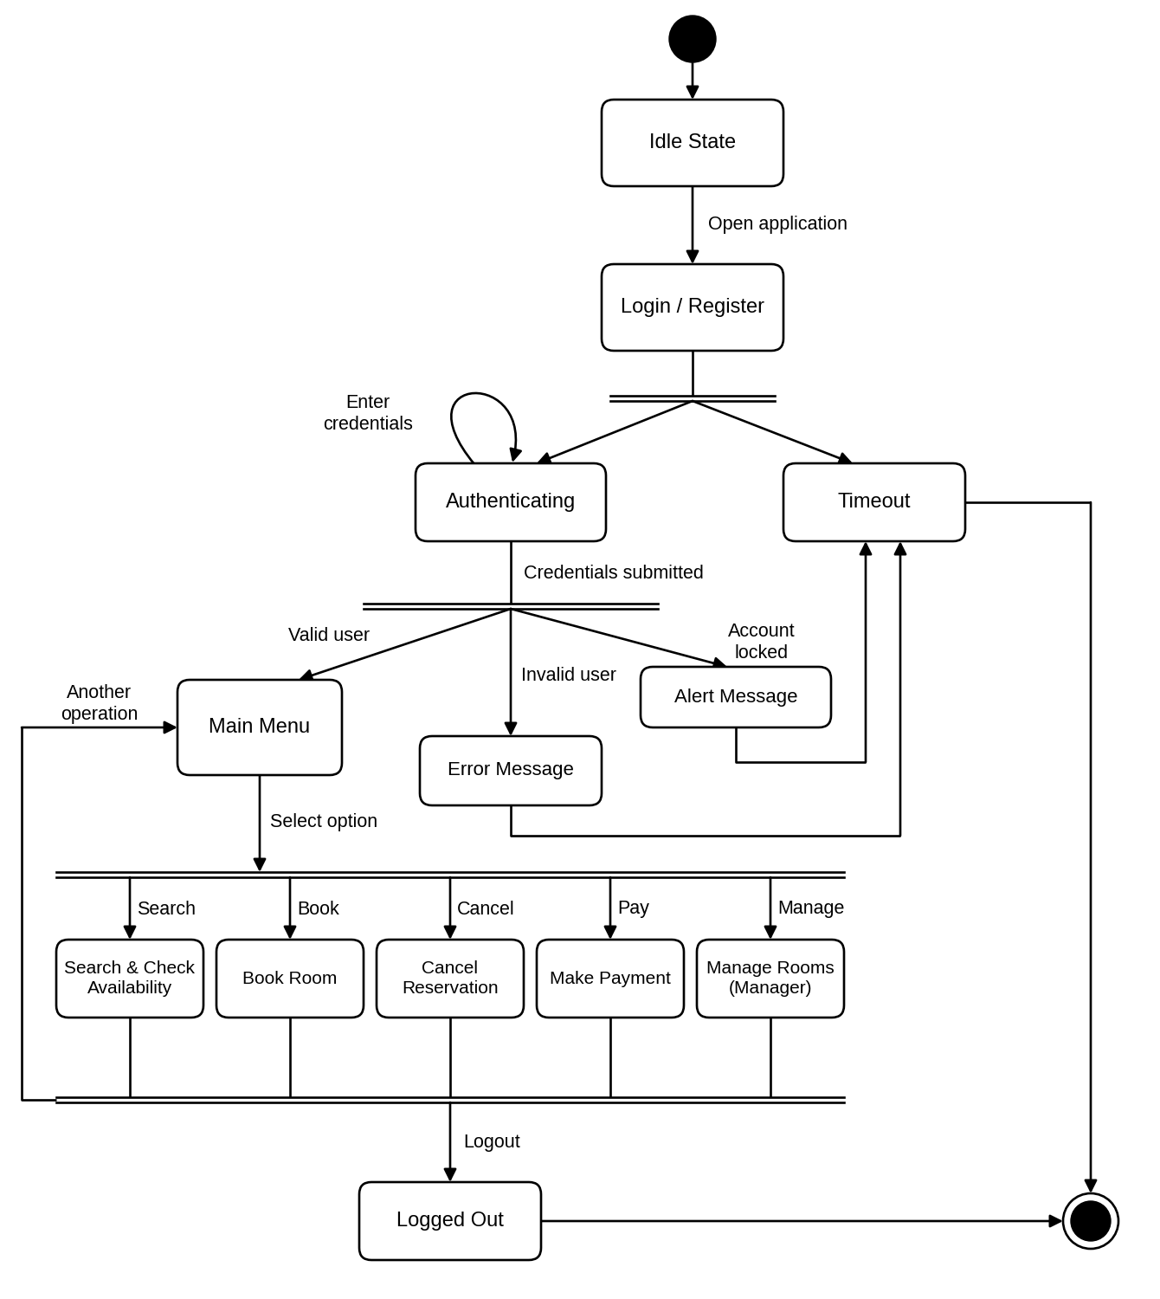
Description
This diagram shows the life cycle of a user session in the Hotel Management System. The system starts at the initial state and stays in the Idle State until the user opens the application. It then moves to Login / Register, where a fork splits the flow into Authenticating and Timeout. If the user does nothing, the system goes to Timeout; otherwise it goes to Authenticating, where the user enters credentials.
After the credentials are submitted, a second fork gives three outcomes. A valid user moves to the Main Menu. An invalid user gets an Error Message, and a locked account gets an Alert Message; both then lead to Timeout, which ends in the final state.
From the Main Menu the user selects one of five operations: Search & Check Availability, Book Room, Cancel Reservation, Make Payment, or Manage Rooms (Manager only). All operations join at a synchronisation bar. From there the user either returns to the Main Menu to perform another operation, or logs out. Logout leads to the Logged Out state and then the final state.
Key Elements
- Initial and final states: The filled circle starts the session; the circle with a ring ends it. Both Timeout and Logged Out lead to the final state.
- States: Idle State, Login / Register, Authenticating, Timeout, Error Message, Alert Message, Main Menu, the five operation states, and Logged Out.
- Fork and join bars: The double lines split the flow into separate outcomes (after login, after credentials, after the menu choice) and join the operations back together.
- Transitions and events: Labelled arrows such as Open application, Credentials submitted, Valid user, Invalid user, Account locked, Select option and Logout.
- Self-transition: The loop on Authenticating shows the user entering credentials before they are submitted.
- Return path: Another operation returns the user from the join bar to the Main Menu.
3. Deployment Diagram
A deployment diagram shows the physical architecture of a system: the hardware nodes and the software artifacts deployed on them.
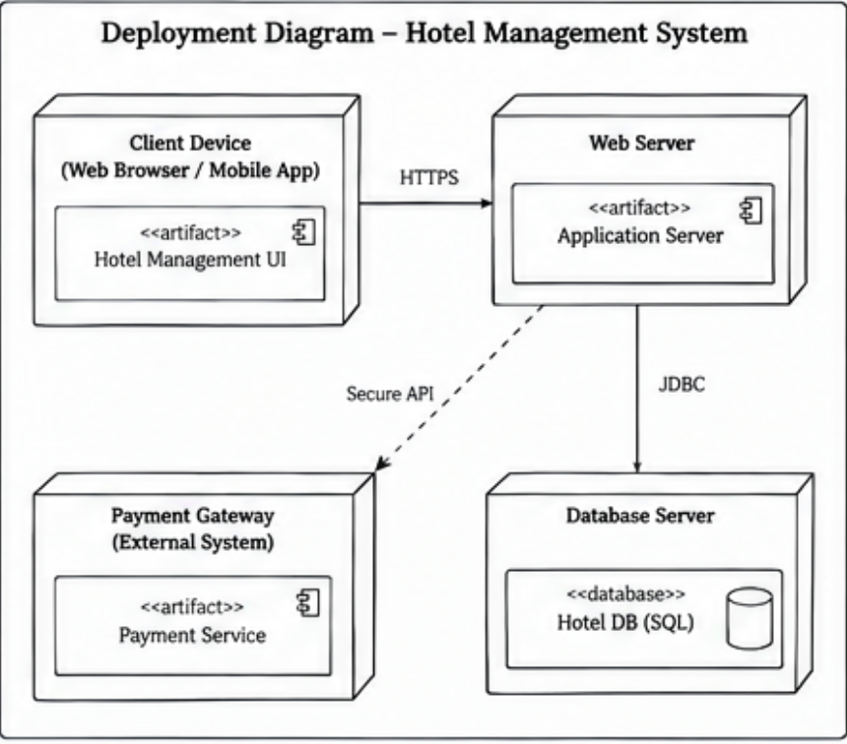
Description
The Client Device (web browser or mobile app) runs the Hotel Management UI artifact and communicates with the Web Server over HTTPS. The Web Server hosts the Application Server artifact, which contains the system logic.
The Application Server connects to the Database Server through JDBC, where the Hotel DB (SQL) database is stored. For online payments, it calls the external Payment Gateway, which runs the Payment Service artifact, through a Secure API, shown as a dashed dependency.
Key Elements
- Nodes: Client Device, Web Server, Database Server and Payment Gateway (external system), drawn as 3D boxes.
- Artifacts: Hotel Management UI, Application Server, Hotel DB (SQL) and Payment Service.
- Communication paths: HTTPS between client and web server; JDBC between web server and database server.
- Dependency: The dashed Secure API line links the web server to the external payment gateway.
4. Activity Diagram
An activity diagram models the workflow of a process as a sequence of actions and decisions; swimlanes show who is responsible for each action.
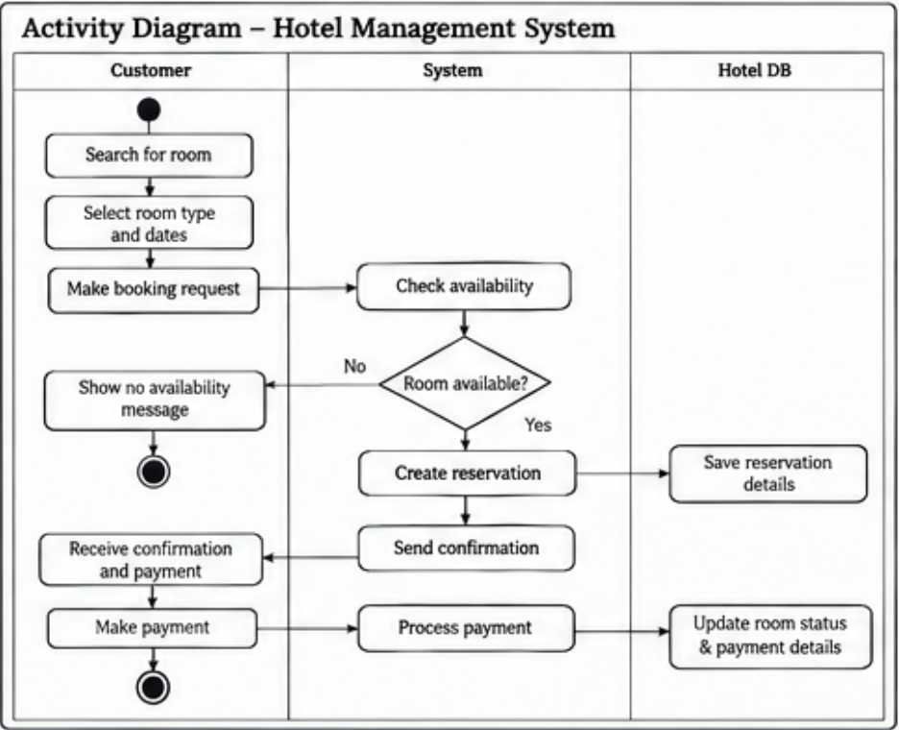
Description
This diagram shows the room booking process with three swimlanes: Customer, System and Hotel DB. The customer searches for a room, selects the room type and dates, and makes a booking request.
The System checks availability. If no room is available, a "no availability" message is shown to the customer and the process ends. If a room is available, the System creates the reservation (saved in the Hotel DB) and sends a confirmation.
The customer receives the confirmation and payment request and makes the payment. The System processes it, and the Hotel DB updates the room status and payment details, completing the process.
Key Elements
- Swimlanes: Customer, System and Hotel DB show who performs each action.
- Actions: Search for room, select room type and dates, make booking request, check availability, create reservation, send confirmation, make payment, process payment.
- Decision node: "Room available?" branches to No (show no availability message) or Yes (create reservation).
- Initial and final nodes: One start node and two end nodes: one for the no-availability path and one for the completed payment.
- Database actions: Save reservation details; update room status and payment details.
5. Use Case Diagram
A use case diagram shows the functions (use cases) a system provides and the actors who interact with them.
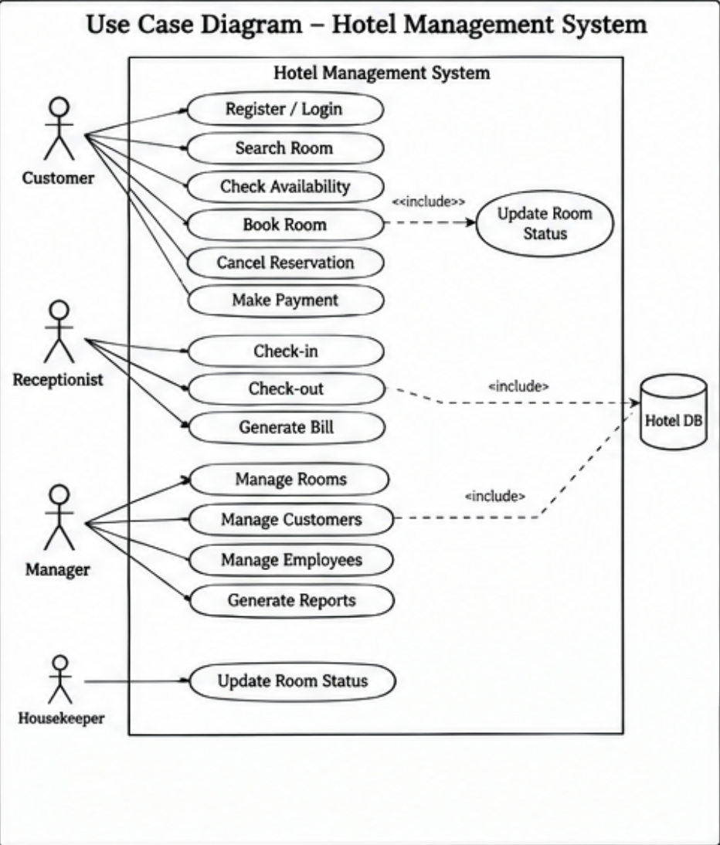
Description
The system boundary is the Hotel Management System, with four actors. The Customer can Register / Login, Search Room, Check Availability, Book Room, Cancel Reservation and Make Payment. Book Room includes Update Room Status.
The Receptionist handles Check-in, Check-out and Generate Bill. The Manager performs Manage Rooms, Manage Customers, Manage Employees and Generate Reports. The Housekeeper updates the room status after cleaning. Check-out and Manage Customers include access to the Hotel DB, which stores all system data.
Key Elements
- Actors: Customer, Receptionist, Manager and Housekeeper.
- System boundary: The rectangle labelled Hotel Management System contains all use cases.
- Use cases: Register / Login, Search Room, Check Availability, Book Room, Cancel Reservation, Make Payment, Check-in, Check-out, Generate Bill, Manage Rooms, Manage Customers, Manage Employees, Generate Reports, Update Room Status.
- Include relationships: Book Room includes Update Room Status; Check-out and Manage Customers include use of the Hotel DB.
- External resource: Hotel DB is shown as a data store used by the system.
6. Component Diagram
A component diagram shows how a system is divided into modular components and the interfaces through which they depend on each other.
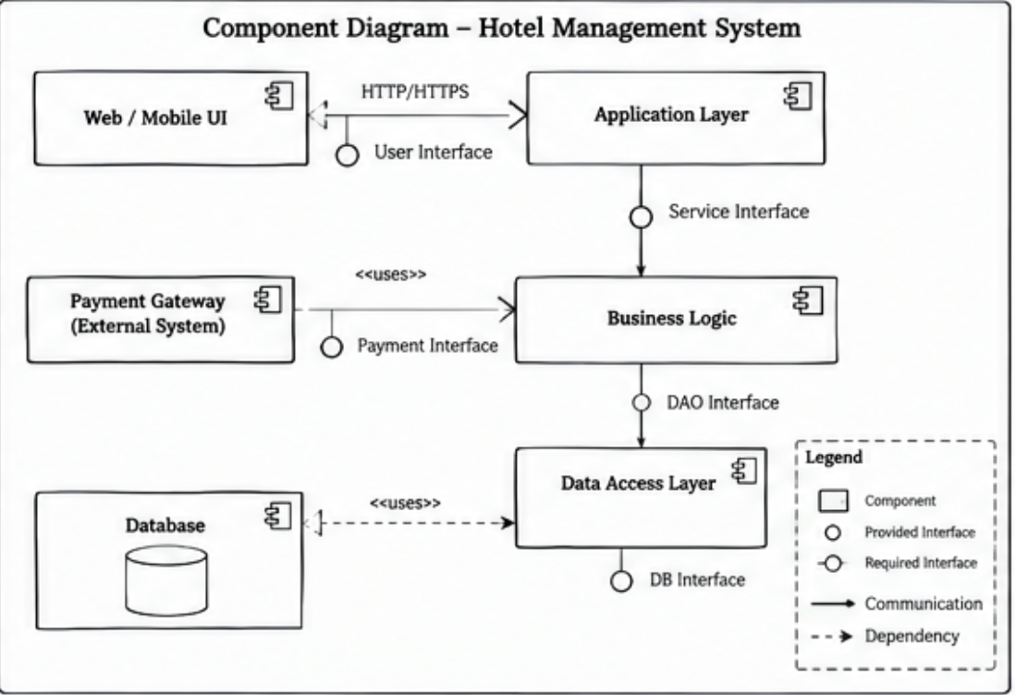
Description
The Web / Mobile UI communicates with the Application Layer over HTTP/HTTPS through the User Interface. The Application Layer calls the Business Logic component through the Service Interface, and Business Logic uses the Payment Gateway (external system) through the Payment Interface.
Business Logic accesses data via the DAO Interface of the Data Access Layer, which uses the Database through the DB Interface. The legend explains the notation: components, provided and required interfaces, solid lines for communication, and dashed lines for dependency.
Key Elements
- Components: Web / Mobile UI, Application Layer, Business Logic, Data Access Layer, Database and Payment Gateway (external).
- Provided interfaces: User Interface, Service Interface, Payment Interface, DAO Interface and DB Interface (lollipop symbols).
- Dependencies: Dashed arrows show Payment Gateway and Database being used by the system layers.
- Layered structure: UI, application, business logic and data access are separated, which makes the system easier to maintain.
- Legend: Explains the symbols for component, provided and required interface, communication and dependency.

